**Explore business report types**

**Introduction**

With Adventure Works due for its quarterly performance review across all departments, your boss requests a clear, concise, and visually appealing set of analytics reports. You know the request isn't just about numbers—it's about crafting a story of data insights that speaks directly to the company's needs. Understanding reports in Microsoft Power BI can empower you to transform raw data into strategic narratives with the support of visualization.

In this reading, you'll learn about different types of business reports in Power BI and their component elements, including the visualizations and insights you can represent within the reports. You'll gain insight into how you can use Power BI to craft strategic narratives from raw data from different business departments.

**The structure of a Power BI report**

A Power BI report is a multi-perspective view of a dataset, complete with visualizations, metrics, and insights represented in different ways. These reports are highly interactive and customizable. A report typically contains multiple pages, each filled with visualizations such as charts, graphs, or maps, as well as other report elements relating to some aspect of the dataset. Reports are vital to monitor, analyze, and communicate key performance indicators, trends, and insights. With its robust reporting capabilities, Power BI makes reporting efficient and insightful.

**Types of business reports**

Let's explore some commonly used reports you can build within Power BI for different business domains, including the sales, marketing, finance, and human resources (HR) departments.

**Sales reports**

Sales reports are pivotal tools for any organization, providing insights into the sales team's performance. Sales managers, directors, and executives typically use sales reports. These reports enable businesses to keep track of revenue, identify top-selling products, understand seasonal trends, measure against sales targets, and gauge the overall health of the company's sales efforts. They can help motivate the sales team and support the team in identifying areas for improvement, setting realistic sales forecasts, and aligning sales strategies with company goals.

In a complex organization like Adventure Works, sales reports are indispensable in coordinating sales efforts across regions and product lines. Sales reports in Power BI can contain a range of visuals with different functions. To give you an idea, a line chart could display monthly sales trends, allowing for easy identification of peak sales periods.

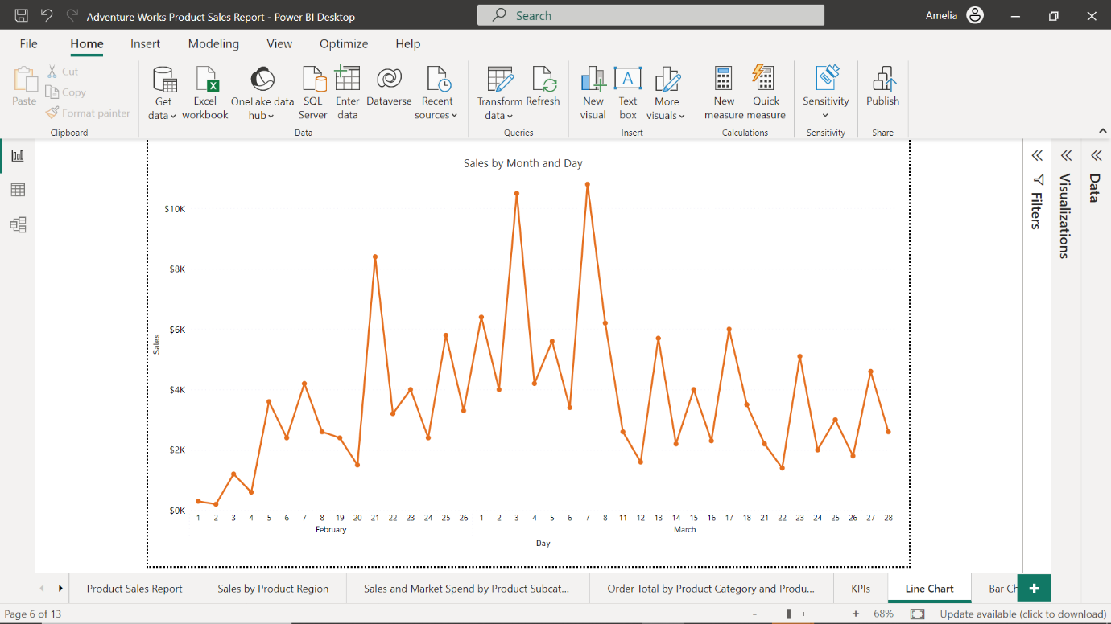

You might use a bar or column chart to compare sales performance across different regions or product categories.

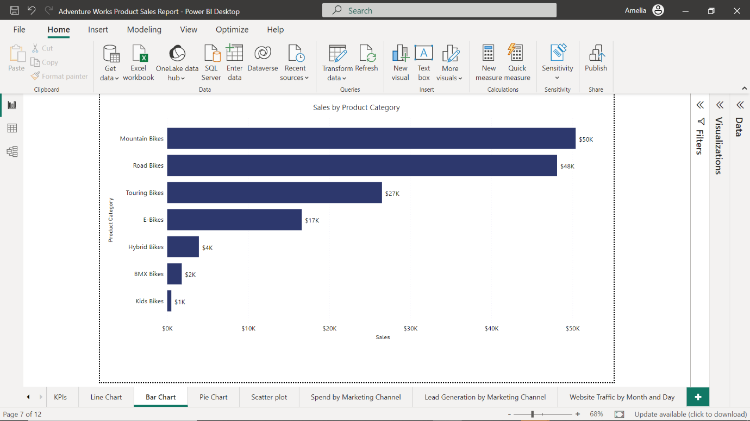

Finally, a pie chart could provide a breakdown of sales by each salesperson, highlighting top performers.

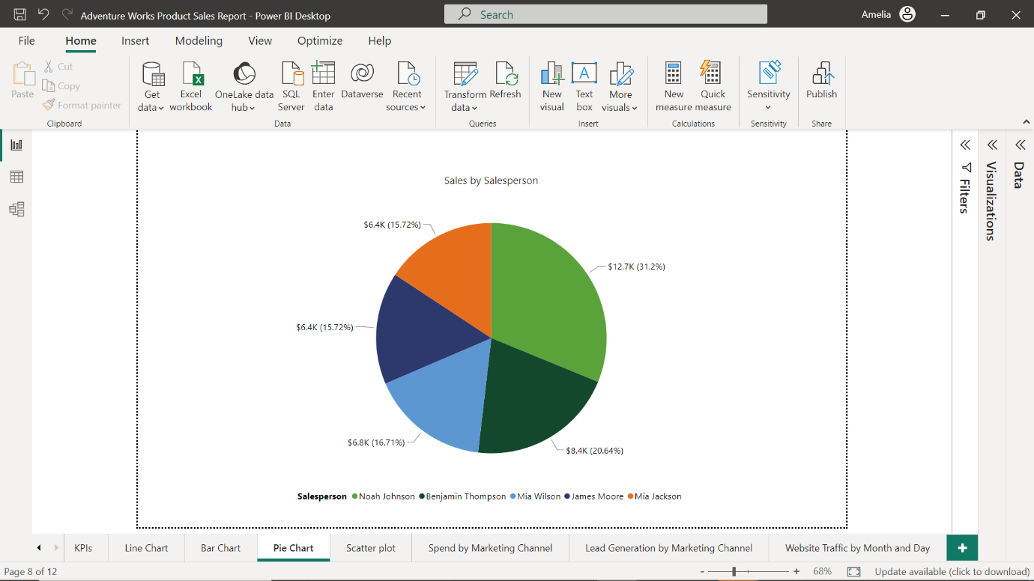

**Marketing reports**

Marketing reports are essential for tracking and analyzing the performance of marketing campaigns. Typically used by marketing professionals, such as managers, executives, Search Engine Optimization (SEO) analysts, and social media coordinators, marketing reports help marketing teams understand their audience, optimize their strategies, and demonstrate the value of their work to stakeholders. These reports provide valuable insights into customer demographics, behavior, and preferences and can be used to measure return on investment (ROI) for various marketing strategies.

Suppose you create a marketing report for Adventure Works. You might use a line chart to track website traffic over time.

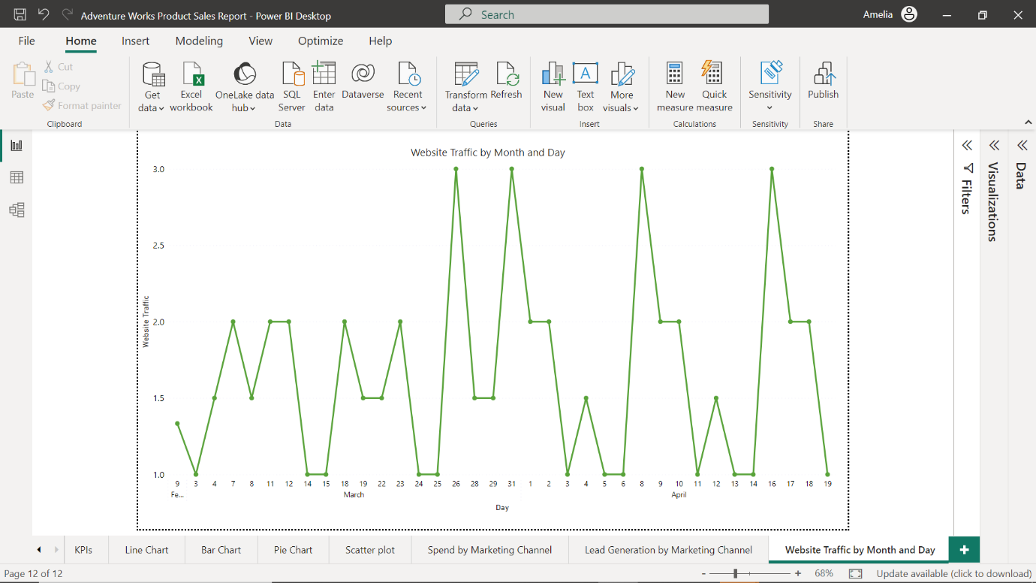

A bar chart could compare lead generation from various marketing channels to determine which channels are performing well in generating customer interest, engagement, and sales, and help the marketing team adjust marketing and sales strategies accordingly.

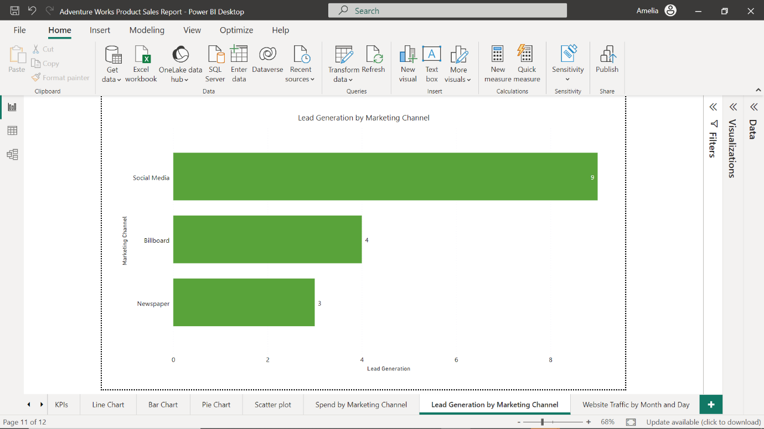

To gain further insight into lead performance, you could include a pie chart that visualizes the distribution of marketing spend across different channels.

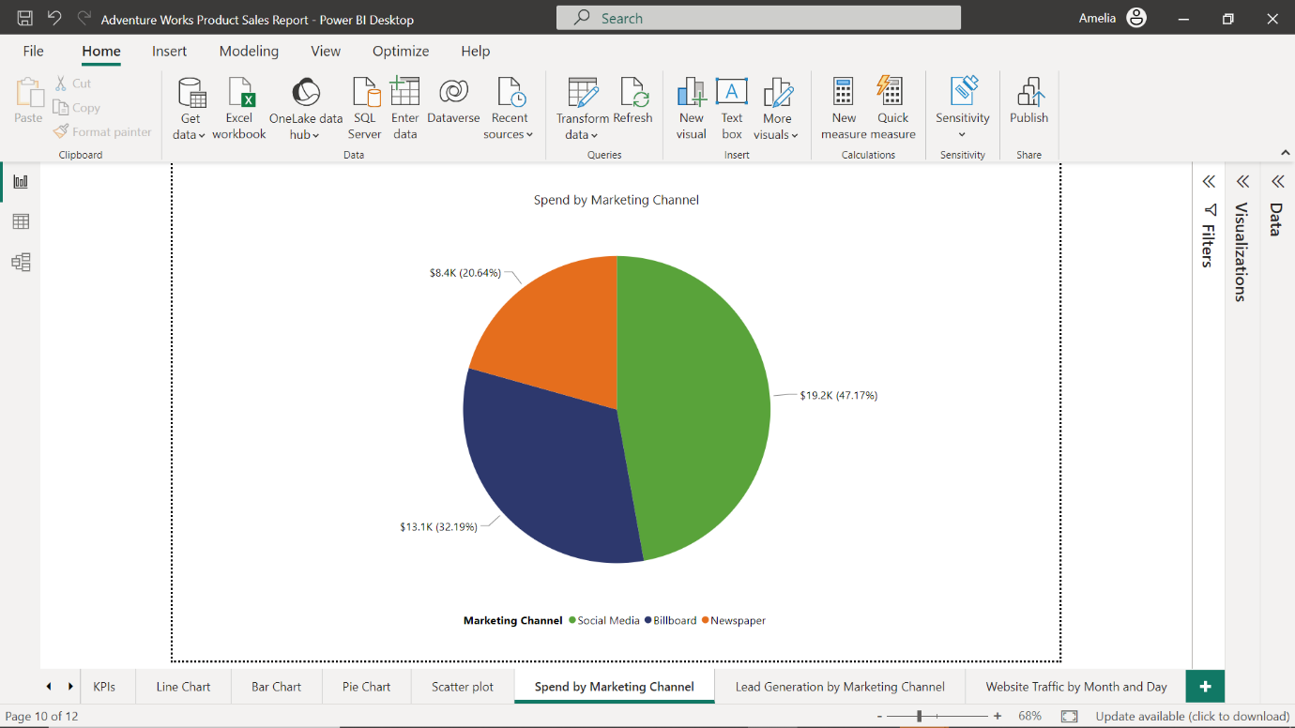

You could also use a scatter chart to analyze the correlation between marketing spend and lead generation.

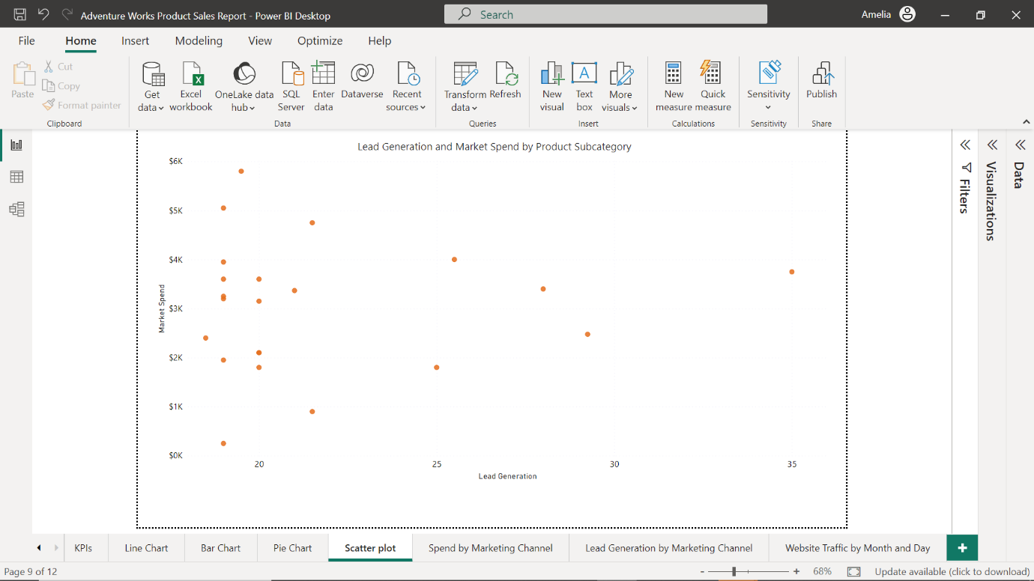

**Financial reports**

Financial reports are fundamental to any business. They provide a detailed picture of the company's financial health, tracking metrics like revenue, expenses, profits, and cash flow. Financial analysts, controllers, Chief Financial Officers (CFOs), and other executives use financial reports. These reports are crucial for making informed financial decisions, planning for growth, ensuring regulatory compliance, and communicating with stakeholders. They help monitor the company's financial performance, plan budgets, evaluate the profitability of different business units, and assess financial risks and opportunities.

A financial report for Adventure Works could use a line chart to track revenue and expenses over time.

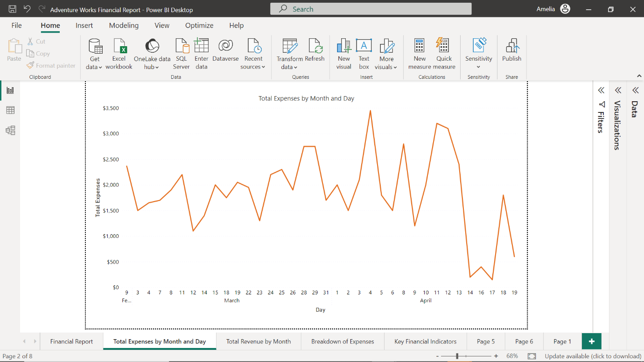

You could use a waterfall chart to illustrate how different revenue and expense categories contribute to the overall net profit.

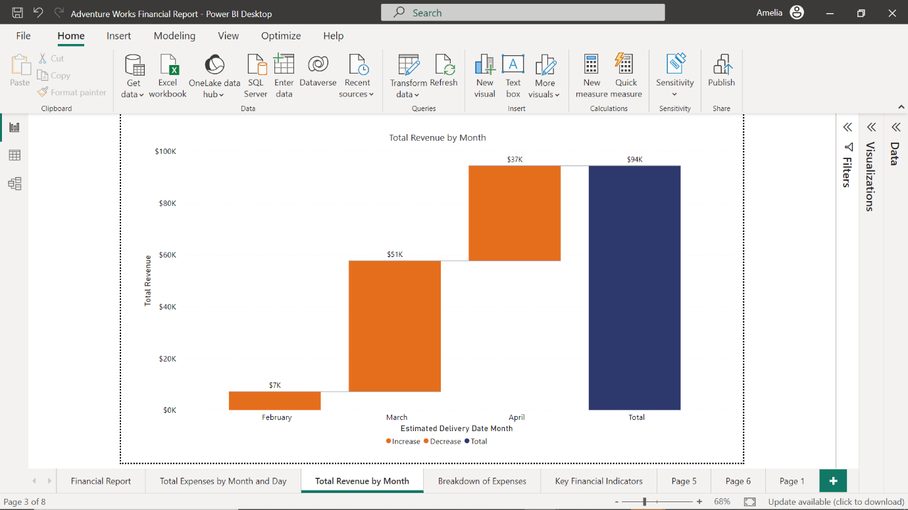

Including tables might be useful to provide a detailed breakdown of expenses.

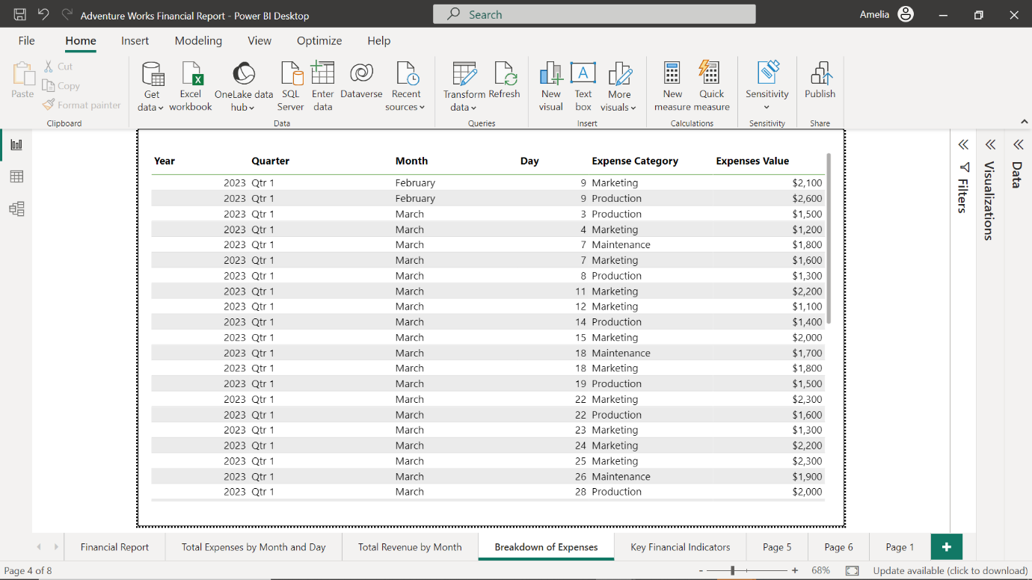

You could also incorporate card visuals to display key financial indicators like gross profit margin or return on assets.

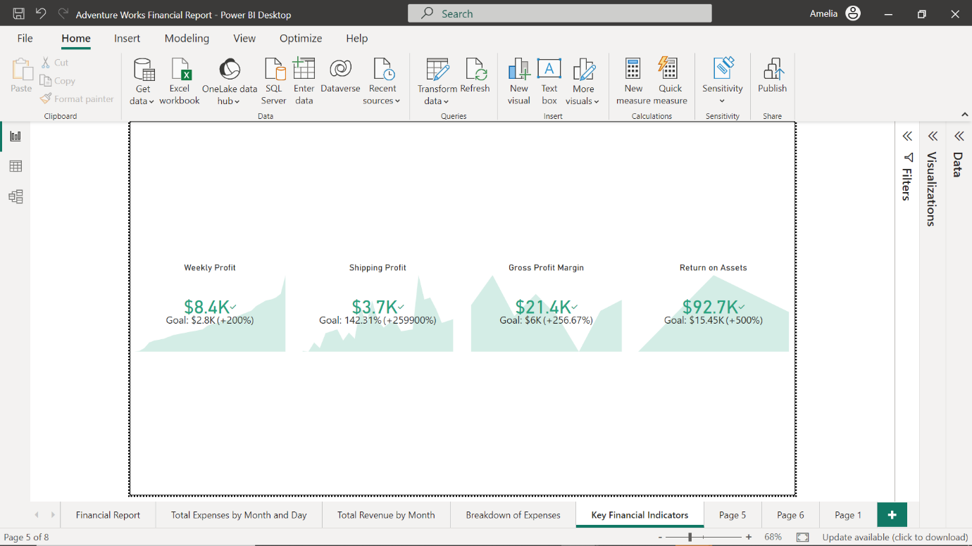

**Human Resources (HR) reports**

HR reports are crucial in managing a company's most important asset—its people. They provide insights into employee demographics, recruitment, turnover, performance, satisfaction, and more. HR managers, recruiters, performance analysts, and executives typically use HR reports. They can support various HR functions like recruitment, retention, performance management, diversity and inclusion, and strategic workforce planning.

You could employ a column chart in an HR report for Adventure Works to visualize the number of employees in each department.

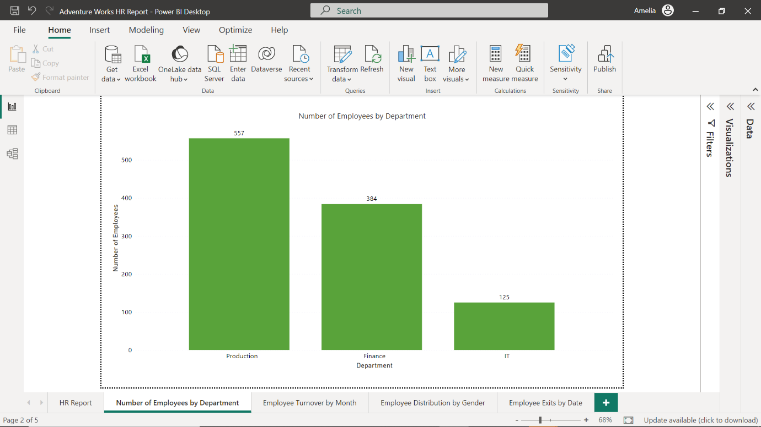

You could use a line chart to track the employee turnover rate over time, to help stakeholders identify any trends in employee attrition (the rate at which employees leave a company over a given period) and factors impacting turnover, as well as inform employee recruitment and retention strategies.

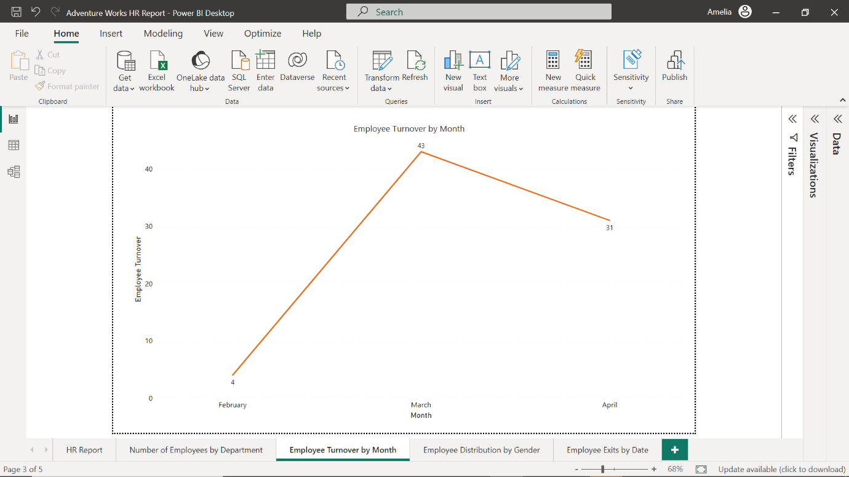

A pie chart could display the distribution of employees by gender or ethnicity, supporting diversity initiatives.

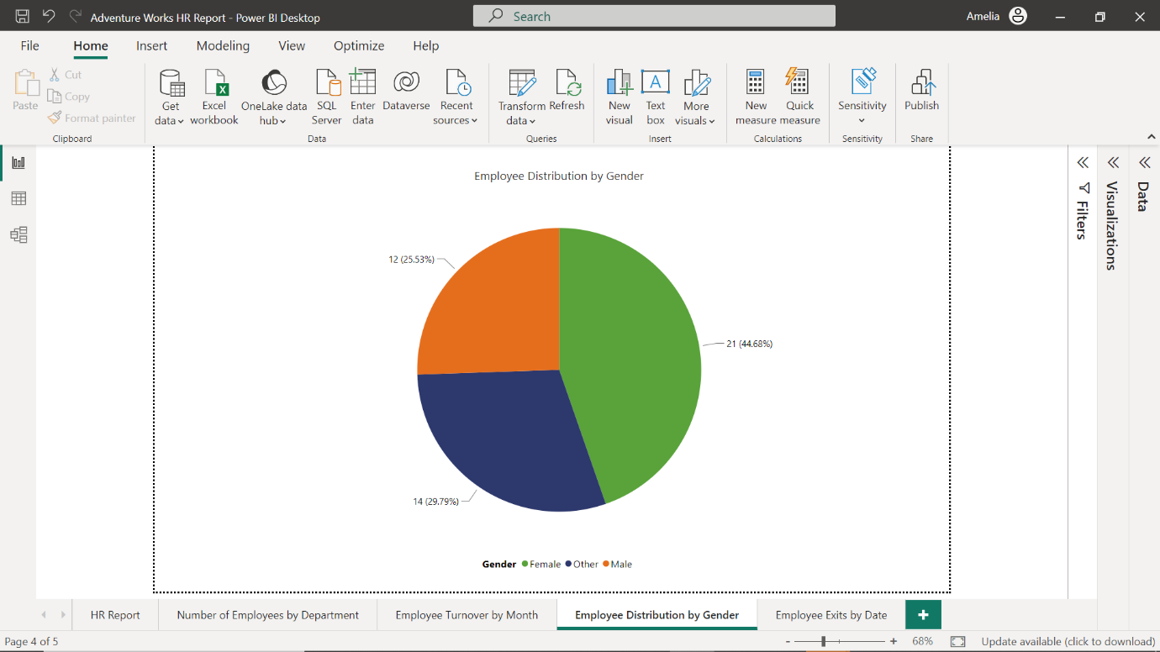

You could also include a table to provide detailed data on new hires or exits. Power BI's advanced features, like Power Query, can also clean, transform, and analyze data, allowing for more sophisticated HR analytics.

